|  |  |  |  |
| --- | --- | --- | --- |
| **Author Name** | **Date** | **Execution Type** | **Platform** |
| Sanjay | 08/83/2020 | Smoke | iPad |

**Pop-up/Banner:**

|  |  |
| --- | --- |
| **Banner Seen** | No |
| **Learn More - Redirection** | No |

**Social Media Links:**

|  |  |  |  |  |  |
| --- | --- | --- | --- | --- | --- |
|  | [**Facebook**](https://www.facebook.com/softvisionusa) | [**Instagram**](https://www.instagram.com/softvisionteam/) | [**Twitter**](https://twitter.com/softvision_usa) | [**LinkedIn**](https://www.linkedin.com/company/softvision) | [**YouTube**](https://www.youtube.com/user/SoftVisionTeam) |
| **Footer** | Yes | Yes | Yes | Yes | Yes |

**Note:** Mark ***‘Yes’*** if the links are working and ***‘No’*** if not inside the respective cells

**Web Pages QA Summary:**

|  |  |  |  |  |
| --- | --- | --- | --- | --- |
| **Page_ID** | **Page_Group_Level** | **Page_Name and URL** | **QA Status** | **Issue Reference** |
| 1 | Level 1 | [Home](https://www.cognizantsoftvision.com/) | FAIL | DEF-18, DEF-21 |
| 2 | Level 1 | [Join our Team - Careers](https://www.cognizantsoftvision.com/careers/) | FAIL | DEF-1, DEF-2, DEF-3, DEF-4,DEF-5, DEF-6, DEF-19 |
| 3 | Level 1 | [Contact +Form](https://www.cognizantsoftvision.com/contact/) | FAIL | DEF-7 |
| 4 | Level 1 | [About Us](https://www.cognizantsoftvision.com/about-us/) | FAIL | DEF-8, DEF-22 |
| 5 | Level 1 | [Privacy Policy](https://www.cognizantsoftvision.com/privacy-policy/) | PASS |  |
| 6 | Level 1 | [Softvision Suite](https://www.cognizantsoftvision.com/softvision-suite/) | FAIL | DEF-9 |
| 7 | Level 1 | [Our Portfolio](https://www.cognizantsoftvision.com/insights/guilds/client-stories/) | PASS |  |
| 8 | Level 1 | [What we do](https://www.cognizantsoftvision.com/services/) | FAIL | DEF-10 |
| 9 | Level 1 | [Our Thoughts](https://www.cognizantsoftvision.com/insights/) | FAIL | DEF-11, DEF-12 |
| 10 | Level 1 | [News](https://www.cognizantsoftvision.com/news/) | PASS |  |
| 11 | TBD | [Virtual Pods](https://www.cognizantsoftvision.com/virtual-pods/) | FAIL | DEF-13 |
| 12 | TBD | [Game of Pods](https://www.cognizantsoftvision.com/game-of-pods/) | FAIL | DEF-20 |
| 13 | Level 2 | [Insights Article](https://www.cognizantsoftvision.com/insights/) | PASS |  |
| 14 | Level 2 | [HWW_Guilds](https://www.cognizantsoftvision.com/guilds/) | FAIL | DEF-14, DEF-15 |
| 15 | Level 2 | [HWW_Pods](https://www.cognizantsoftvision.com/pods/) | PASS |  |
| 16 | Level 2 | [HWW_Our Approach](https://www.cognizantsoftvision.com/our-approach/) | PASS |  |
| 17 | Level 2 | [HWW_Studios](https://www.cognizantsoftvision.com/our-studios/) | FAIL | DEF-16 |
| 18 | Level 2 | [Join our Team - Trainings](https://www.cognizantsoftvision.com/trainings/) | PASS |  |
| 19 | Level 2 | [Join ourTeam - Women at CSV](https://www.cognizantsoftvision.com/women-at-cognizant-softvision/) | PASS |  |
| 20 | Level 2 | [Inventory Planning](https://www.cognizantsoftvision.com/inventory-planning-replenishment-page/) | FAIL | DEF-17, DEF-13, DEF-14 |

# DEF-1 | Join our Team-Careers | Overlapped Numbering

**Description:** On careers Our Openings section click any link and observe, the numbering is found overlapped.

**Steps to reproduce:**

1. Go to<https://www.cognizantsoftvision.com/careers/>
2. Click on any link in **Our Openings** section.
3. Click on **PROCEED** on **Candidate Privacy Notice.**
4. The first numbering seen in the page is seen hidden.

**Expected:** The numbering has to come right beside Description.

**Actual:** The first numbering is overlapped.

**Reference:**

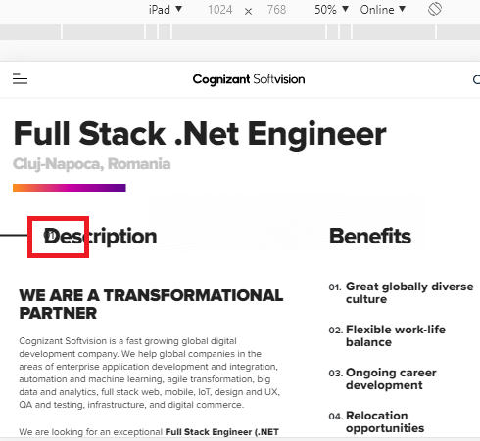

# DEF-2 | Join our Team-Careers | YouTube video volume not present

**Description:** The volume button is not present when YouTube video is played in the page and hence no volume when played.

**Steps to reproduce:**

1. Go to<https://www.cognizantsoftvision.com/careers/>
2. The volume button is not present when YouTube video is played in the page.

**Note:**  All the You Tube videos present in the page doesn’t have volume button and no audio.

**Expected:** The volume button should be present to adjust the volume.

**Actual:** The volume button itself is not present, hence there is no volume when played the YouTube video.

**Reference:**

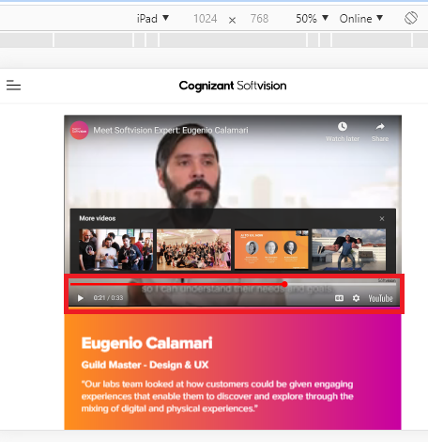

# DEF-3 | Join our Team-Careers | Link is not redirecting

**Description:** On LCA Notices pdf the links are not redirecting to its respective page

**Steps to reproduce:**

1. Go to<https://www.cognizantsoftvision.com/lca-notices/>
2. Click on any link
3. observe

**Expected:** Clicking on any link should navigate to its respective page

**Actual:** Clicking on any link is not navigating to its respective page

**Reference:**

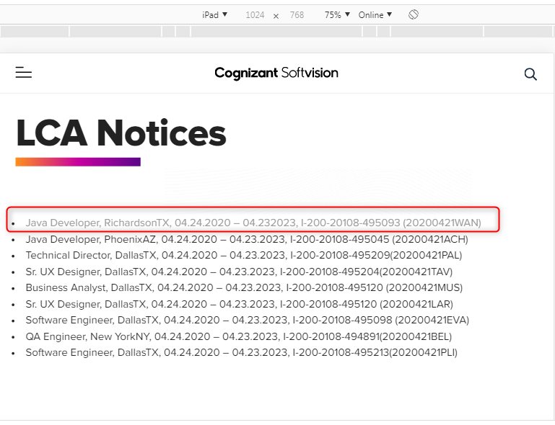

# DEF-4 | Join our Team-Careers | Extension of the file format not seen

**Description:** When tried to apply for a particular job profile without a resume the file extension is not seen completely

**Steps to reproduce:**

1. Click on <https://www.cognizantsoftvision.com/enterprise-software-guild/full-stack-net-engineer/2622/>
2. Click on proceed
3. Scroll down and Apply
4. Fill the form without resume attached
5. Check on “I ‘m not a Robot”
6. And observe below upload resume button

**Expected:** Extension of the file format should be seen completely

**Actual:** Extension of the file format not seen completely

**Note:** Observe in all available Jobs

**Reference:**

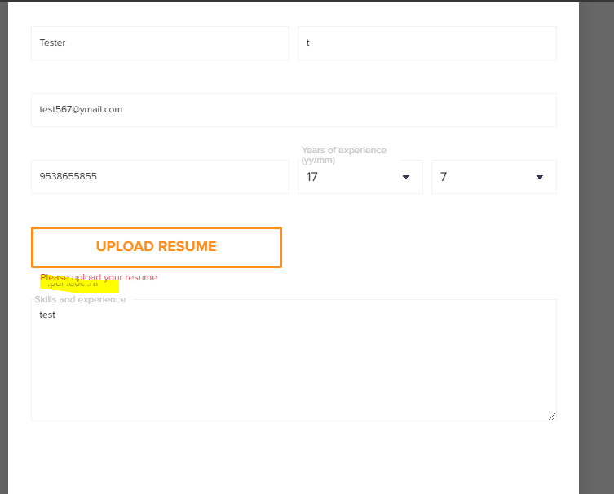

# DEF-5 | Career | Discrepancy observed after footer

**Description**: If we search for Bangalore location we must get only Bangalore location but we are getting Mysore in the title which leads to confusion

**Steps to reproduce:**

1. Go to <https://www.cognizantsoftvision.com/careers/positions/location/bangalore/guild/all-guilds/> (Career page)
2. Select Studios/Location as Bangalore
3. Check the result

**Expected:**  Vacancies in Bangalore Location should be shown as there was a filter only for Bangalore location

**Actual:** In title we have (Mysore) but filter applied is only for Bangalore location which leads to confusion

**Reference:**

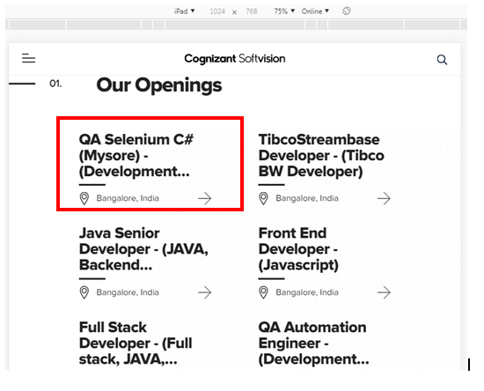

# DEF-6 | Careers | “I‘m not a robot” is inconsistent

**Description: T**o check the check box of “I‘m not a robot” it behaves inconsistent and “ I am not a robot” captcha questions are not asked.

**Steps to reproduce:**

1. Click on <https://www.cognizantsoftvision.com/enterprise-software-guild/full-stack-net-engineer/2622/>
2. Click on proceed
3. Scroll down and Apply
4. Fill the form without resume attached
5. Check on “I‘m not a robot”
6. And observe

**Expected: T**o check the check box of “I‘m not a robot” it should allow with the captcha questions

**Actual: T**o check the check box of “I‘m not a robot” it might or might not allow and the captcha questions are not asked

**Reference:**

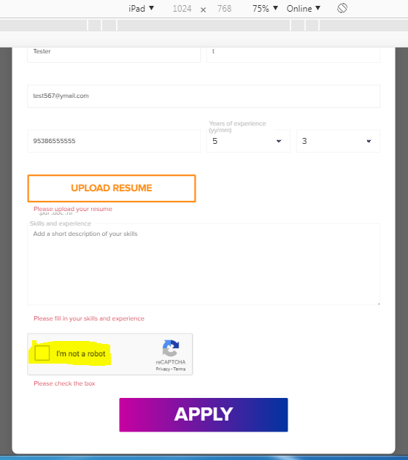

# DEF-7 | [Contact +Form](https://www.cognizantsoftvision.com/contact/) | Without attachment form can be submitted

**Description:** Without attachment, form can be submitted in contact page

**Steps to reproduce:**

1. Go to <https://www.cognizantsoftvision.com/contact/>
2. Fill the form by selecting “Work with Us (Careers)”
3. Without adding attachment submit the form
4. We receive “Thanks for submitting the form”

**Expected:** Without attachment, Form should not be submitted

**Actual:** Without attachment, Form is submitted

**Reference:**

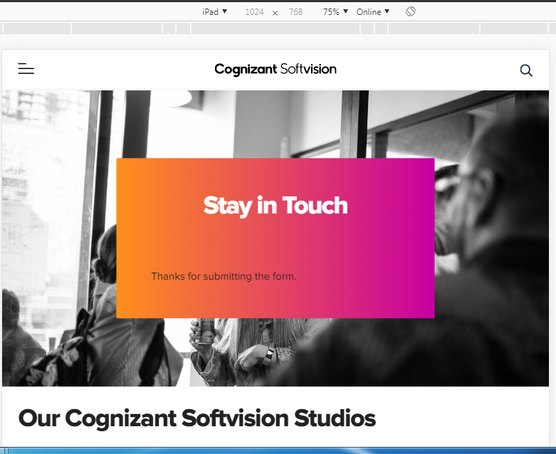

# DEF-8 | About us Page| Title overlap and text alignment

**Description:** Title is not clear and alignment is not as per design.

**Steps to reproduce:**

1. Open [About Us](https://www.cognizantsoftvision.com/about-us/) page.
2. Observe the title and description.

**Expected:** Title must be clear and text alignment should be as per design.

**Actual:** Title overlapping and text alignment is not as per design.

**Reference:**

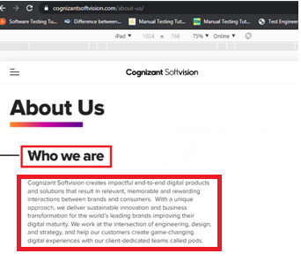

# DEF-9 | [Softvision](https://www.cognizantsoftvision.com/guilds-list/mobile-2/) Suite | “Request A Demo” Button is not working

**Description:**“Request A Demo” button is not functioning

**Steps to reproduce:**

1. Click on [Softvision Suite](https://www.cognizantsoftvision.com/softvision-suite/)
2. Scroll down
3. Click on “Request A Demo”
4. Observe

**Expected:** Button should work upon clicking it

**Actual:** Button is not working upon clicking it

**Reference:**

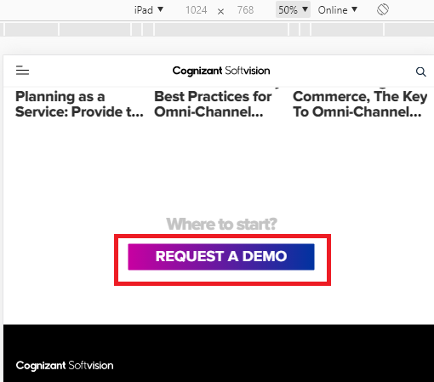

# DEF-10 | What we Do | YouTube video volume not present

**Description:** The volume button is not present when YouTube video is played in the page and hence no volume when played.

**Steps to reproduce:**

1. Go to<https://www.cognizantsoftvision.com/services/>
2. The volume button is not present when YouTube video is played in the page.

**Expected:** The volume button should be present to adjust the volume.

**Actual:** The volume button itself is not present, hence there is no volume when played the YouTube video.

**Reference:**

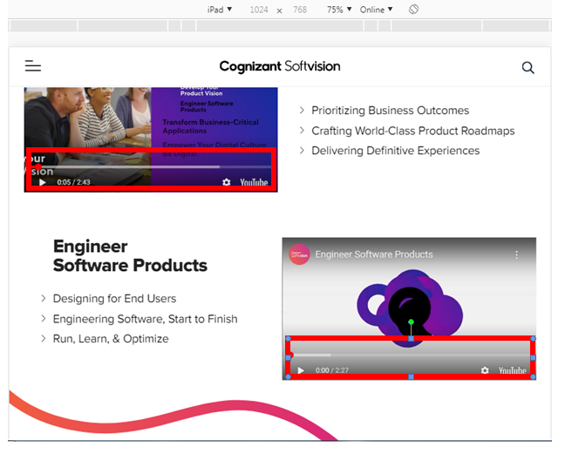

# DEF-11 | Our Thoughts | Heading is not aligned

**Description**: Heading is not completely seen and aligned

**Steps to reproduce:**

1. Click <https://marketing.softvision.com/transforming-while-performing?__hstc=61581043.ca07fa30b96e90ed0fd4163699012f44.1592906671054.1592906671054.1592906671054.1&__hssc=61581043.1.1592906671055&__hsfp=1229146266>
2. Observe

**Expected:** Heading should be completely seen and aligned as per the design

**Actual:** Heading is not completely seen and aligned

**Reference:**

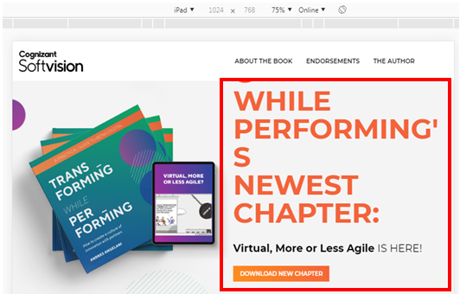

# DEF-12 | Our Thoughts| Discrepancy before and after applying filters

**Description**: First time when we land on Our Thoughts without applying filters we find “CHECK OUT OUR LATEST BOOK” then apply filter by checking any one option from the drop down, “CHECK OUT OUR LATEST BOOK” disappears.

Later remove all the filters and scroll even now we must get “CHECK OUT OUR LATEST BOOK” (I.e. before applying filter and after removing the filter it must match) but we don’t find it

**Steps to reproduce:**

1. Under “Our Thoughts” first time we find “CHECK OUT OUR LATEST BOOK”
2. With filter “CHECK OUT OUR LATEST BOOK” disappears
3. Now remove filter and observe
4. “CHECK OUT OUR LATEST BOOK” should display

**Expected:**  The design before applying filter and after removing the filter it must match

**Actual:** The design before applying filter and after removing the filter is not matching

**Reference:**

After removing the filters applied

**Note:** Observe with adding filters and also removing the filters.

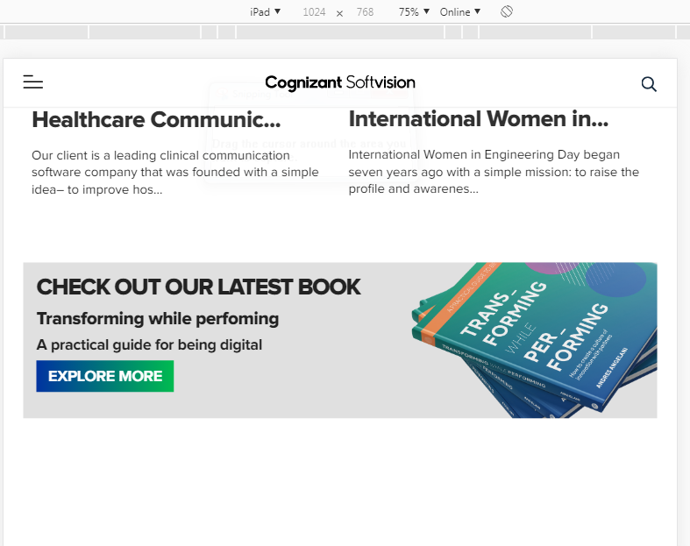

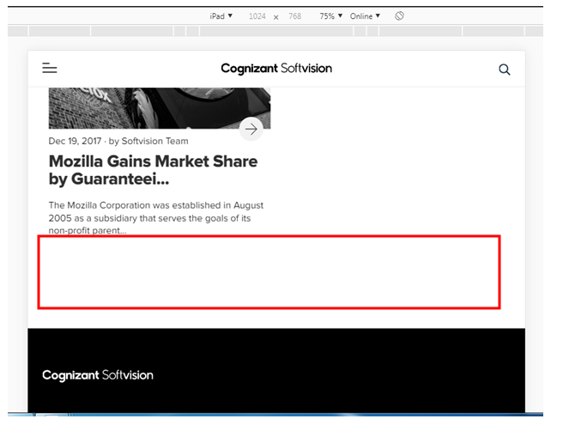

# DEF-13 | Virtual-Pods | Button is not working

**Description**: “Get in Touch” button is not functioning

**Steps to reproduce:**

1. Go to <https://www.cognizantsoftvision.com/virtual-pods/>
2. Scroll down completely
3. Click and Observe “Get in Touch” button

**Expected:**  Button should open its respective page

**Actual:** Button is not Opening its respective page

**Reference:**

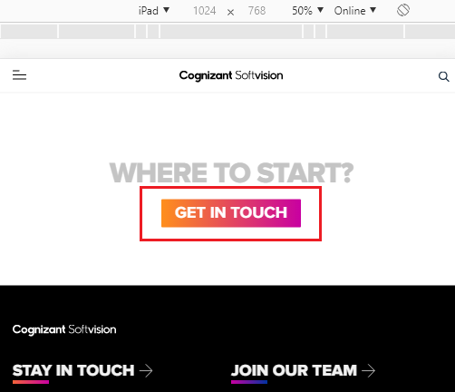

**Note:** Same issue observed on [Inventory Planning](https://www.cognizantsoftvision.com/inventory-planning-replenishment-page/)

# DEF-14 | HWW-Guilds | YouTube video volume not present and sound not audible when played

**Description:** The volume button is not present when YouTube video is played in the page and hence no volume when played.

**Steps to reproduce:**

1. Go to<https://www.cognizantsoftvision.com/guilds/>
2. The volume button is not present when YouTube video is played in the page.

**Expected:** The volume button should be present to adjust the volume.

**Actual:** The volume button itself is not present, hence there is no volume when played the YouTube video.

**Reference:**

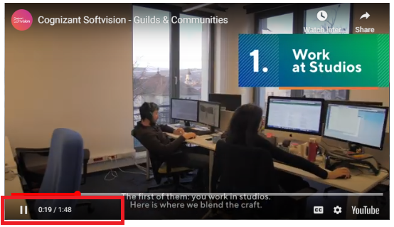

**Note: Same issue is also observed on** [HWW_Pods](https://www.cognizantsoftvision.com/pods/)**,** [HWW_Studios](https://www.cognizantsoftvision.com/our-studios/)**,** [Join ourTeam - Women at CSV](https://www.cognizantsoftvision.com/women-at-cognizant-softvision/)**,** [HWW_Our Approach](https://www.cognizantsoftvision.com/our-approach/), [Inventory Planning](https://www.cognizantsoftvision.com/inventory-planning-replenishment-page/) **and** [Virtual Pods](https://www.cognizantsoftvision.com/virtual-pods/)

# DEF-15 | HWW Guilds| Video is not being played

**Description**: In the engineering design inside “Quality Engineering” link video can’t be played

**Steps to reproduce:**

1. Click on [HWW_Guilds](https://www.cognizantsoftvision.com/guilds/)
2. Scroll down to the design
3. Click on Quality Engineering
4. Try playing the video on the child page

**Expected:** Video played on any page must play

**Actual:** Video in the child page is not playing

**Reference:**

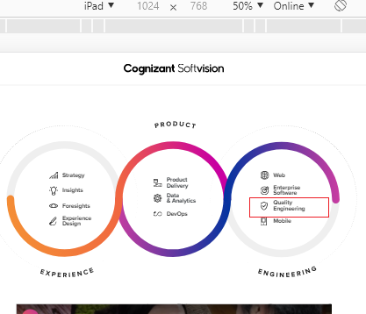

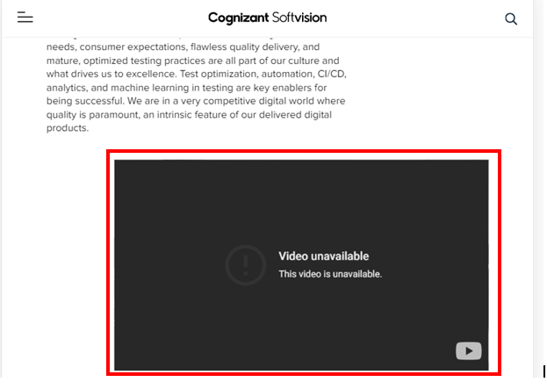

# DEF-16 | HWW Studios | Curve missing

**Description**: Wave curve is expected in the highlighted area

**Steps to reproduce:**

1. Click on [HWW_Studios](https://www.cognizantsoftvision.com/our-studios/)
2. Scroll and observe

**Expected:**  On [HWW_Studios](https://www.cognizantsoftvision.com/our-studios/) page a wave curve is expected in the highlighted area

**Actual:**On [HWW_Studios](https://www.cognizantsoftvision.com/our-studios/) page a wave curve is not displayed on highlighted area

**Reference:**

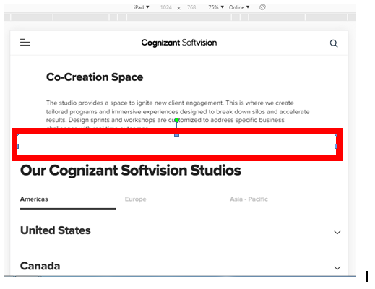

# DEF-17 | Inventory Planning | Unable to swipe right side

**Description:** Unable to see all the subheading completely and unable to swipe right to choose other cards

**Steps to reproduce:**

1. Click on [Inventory Planning](https://www.cognizantsoftvision.com/inventory-planning-replenishment-page/)
2. Below “What you can achieve with it”
3. Try swiping

**Expected:** Must be able to read the last highlighted word and unable to swipe

**Actual:** Unable to read the last highlighted word and unable to swipe

**Reference:**

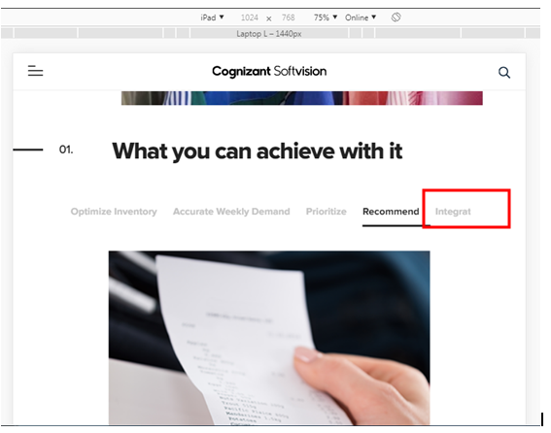

# DEF-18 | Home | Volume control button fails

**Description**: In Home Page sound button is not working video plays with no sound

**Steps to reproduce:**

1. Go to <https://www.cognizantsoftvision.com/>
2. Click on Mute /Unmute button
3. Observe

**Expected:** Video should have sound when clicked on Sound button.

**Actual:** There is no sound when clicked on Sound button.

**Reference:**

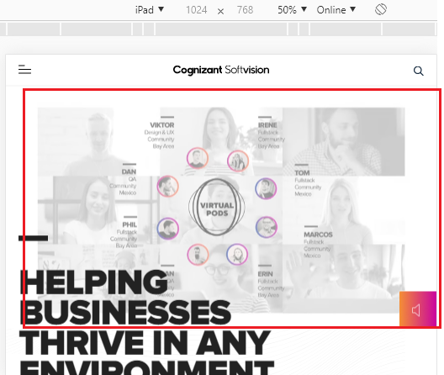

# DEF-19 | Join Our Team| Spacing issue

**Description:** The line highlighted should be equi spaced below all the openings

**Steps to reproduce:**

1. Go to [Join our Team - Careers](https://www.cognizantsoftvision.com/careers/)
2. Scroll below and Observe

**Expected:** The line highlighted should be equi spaced below all the openings

**Actual:** The line highlighted are not equi spaced below all the openings

**Reference:**

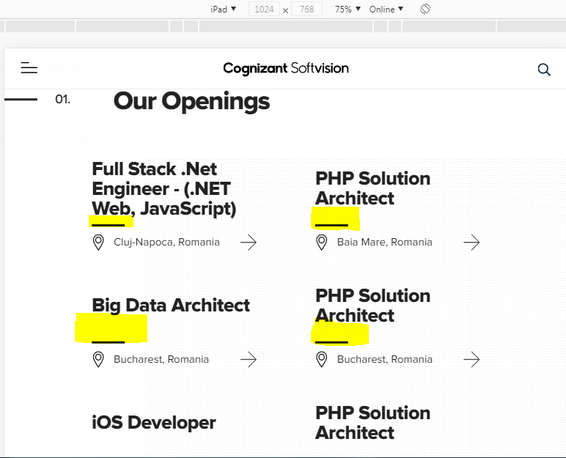

# DEF-20 | Game of Pods| Add video to Game of Pods landing page

**Description**:  **Video is not seen on GOP landing page**

Tracked under CSV-797

**Reference:**

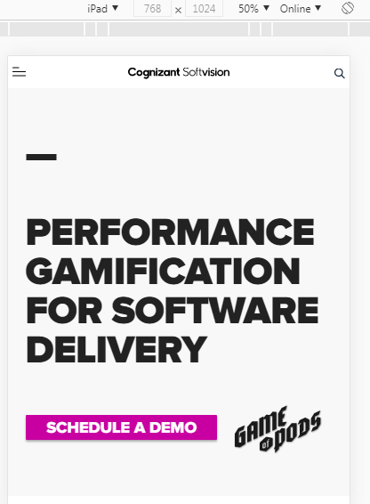

# DEF-21 | Home | Button is not working

**Description**: “Submit” button is not functioning

**Steps to reproduce:**

1. Click on [Home](https://www.cognizantsoftvision.com/)
2. Go to “Section 01” in home page.
3. Click on any link. Example: **Binny’s** Links
4. Scroll down completely.
5. Fill the details and observe “Submit” button.

**Expected:**  Button should submit the form.

**Actual:** Button is not submitting the form.

**Reference:**

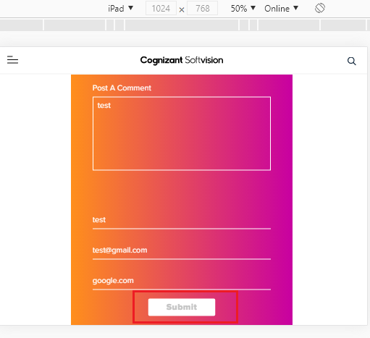

# DEF-22 | About Us| Link is not redirecting

**Description:** On Leadership the links are not redirecting to its respective page

**Steps to reproduce:**

1. Go to [About Us](https://www.cognizantsoftvision.com/about-us/)
2. Click on **Tom Delbrook** link
3. Observe

**Note:** Same issue is also observed on **Snjezana Cvoro-Begovic**, **Girish Karunakaran**, **Ines Casares**, **Mihai Constandis**, **Raul Rodila** and **David Bolcsfoldi**

**Expected:** Clicking on **Tom Delbrook** link should navigate to its respective page

**Actual:** Clicking on **Tom Delbrook** link is not navigating to its respective page

**Reference:**

